NETWORK INTERFACE AND SECURITY ENHANCEMENTS

SECURITY GROUP
- it is a virtual firewall works at ENI level. (instance level)
- You can attach multiple Security Groups to one EC2 instance (up to 5 by default).
- can only have permit rules, cannot have deny rule.
- It is a stateful, return traffic is automatically allowed in outbound rule, even if there are no rules to allow it.

NACL (network access control list)
- NACL is an optional layer of security for your VPC that acts as a firewall for controlling traffic in and out of one or more subnets.
- it works at subnet level.
- It is a stateless, return traffic is not automatically allowed
- Supports both allow as well as deny the rule

ELASTIC IP
- Elastic IP is nothing but a static public IPv4 address provided by amazon web services
- commonly used for websites, APIs, or SSH access where a stable IP is required.
- AWS charges for unused Elastic IPs to prevent waste, so you should only allocate when needed.

PRACTICAL ON ELASTIC IP
1.Create A Instance
- name ------------> webserver
- machine --------> ubuntu
- instance type --> t3. micro
- create a instance
2.Allocate Elastic Ip Address
- Go to Elastic IPs section
- Click Allocate Elastic IP Address
- Click Allocate
3.Associate Elastic IP with Instance
- Select the allocated Elastic IP Address
- Click on Actions → Associate Elastic IP Address
- Choose:
- Resource Type → Instance
- Instance → webserver
- Click Associate
4.Verify
- Now your instance has a static public IP Address
- Stop and start the instance → Elastic IP will NOT change
- (Normal public IP changes, but Elastic IP stays same)

PLACEMENT GROUPS
A placement group is a concept used in cloud computing to control how your compute resources (like virtual machines/instances) are physically placed on underlying hardware.
- Low latency (fast communication between instances)
- High availability (avoid failures affecting multiple instances)
- High throughput (better network performance)
Types of placement groups
- Cluster Placement Group
  - Places instances very close together in the same Availability Zone.
  - Achieve low latency and high network throughput.
  - Uses
1. High-performance computing (HPC)
2. Big data workloads
3. Distributed databases
4. It is Best when you need fast communication between instances.

- Spread Placement Group
  - Places instances far apart across different hardware (racks).
  - Reduce risk of simultaneous hardware failure.
  - Max 7 instances per AZ.
  - Use cases:
- Critical applications
- Small number of important instances
  - Best for high availability.
- Partition Placement Group
  - Divides instances into logical partitions, each on separate hardware.
  - Limit failure impact to only one partition.
  - Use cases:
- Large distributed systems like Hadoop, Kafka, Cassandra
  - Balance between performance and fault tolerance.

WHAT IS NIC CARD
- NIC is a network interface card
- It is hardware device that allows a computer to connect to a network or the internet.
- Without a NIC, a computer cannot communicate with other devices on a network.

What NIC DO
- Provides a physical connection to the network
- Has a MAC address (unique identity of the device)
- Converts data into signals for transmission

Types of NIC
- internal network card
- External network card

Internal Network Card
- Installed inside the computer (on motherboard or PCI slot)
- Mostly used in desktops
- Uses Ethernet cable (RJ45) for connection
- Today, many motherboards have built-in NIC (LAN port)
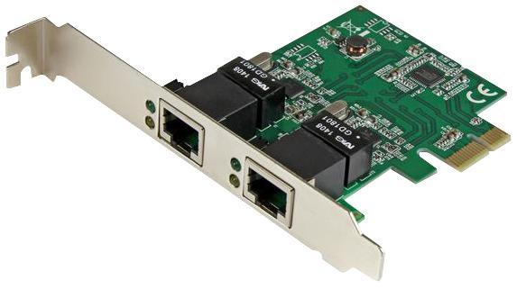
External Network Card
- Used when internal NIC is not available or not working
- Connected via USB port
- Common in laptops or compact devices
- It is two types:
- Wired (USB to Ethernet) → uses LAN cable
- Wireless (Wi-Fi adapter) → connects without cable


HOW TO ASSIGN NIC TO A SERVER
1.create a instance
- name -------> webserver
- machine ---> ubuntu
- type --------> t3. micro
- create a instance

2.click on EC2 -----> network interfaces
- create a network interface
- description -----> Nic2
- subnet -----------> choose subnet where u instance is
- sg -----------------> select
- create a NIC card

3.click on created NIC card
- click on action -----> attach
- vpc -------> select vpc
- instance -----> select the instance (webserver)
- attach

4.click on sever
- you get two private ips
- also check the NIC (you get two nic card)

